2813 NW 122nd Street

Oklahoma City, OK 73120

**5030 N. May Ave, #435**

**Oklahoma City, OK 73112**

**WWW.AVENUECRE.COM**

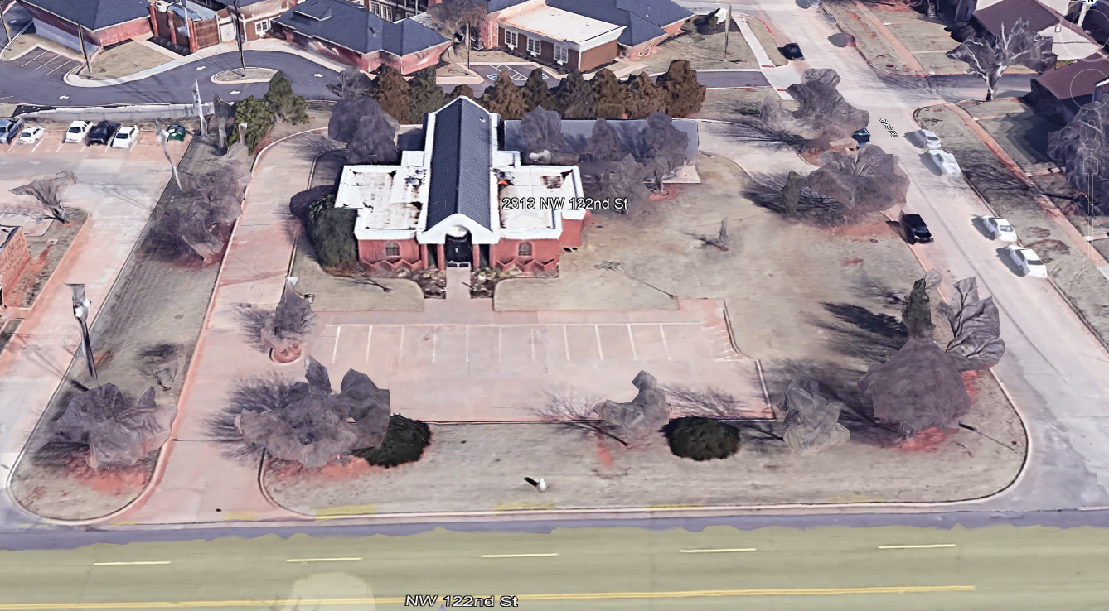

Trail Oak Drive

NW 122nd Street

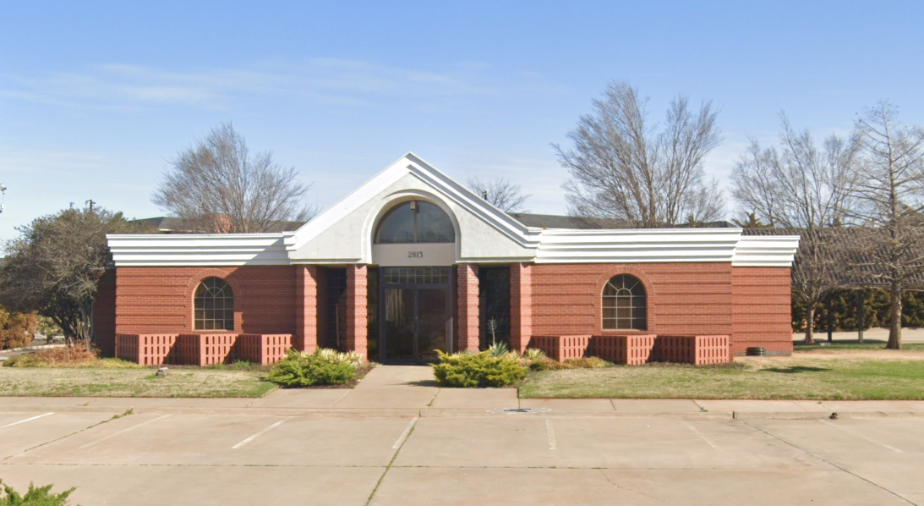

* Ingress/Egress to NW 122nd Street
* Ingress/Egress to Trail Oaks Blvd.

RANDY VAILLANCOURT

RANDY VAILLANCOURT

**5030 N. May Ave, #435**

**Oklahoma City, OK 73112**

**WWW.AVENUECRE.COM**

Managing Broker

405.210.6772 (mobile)

randy@avenuecre.com

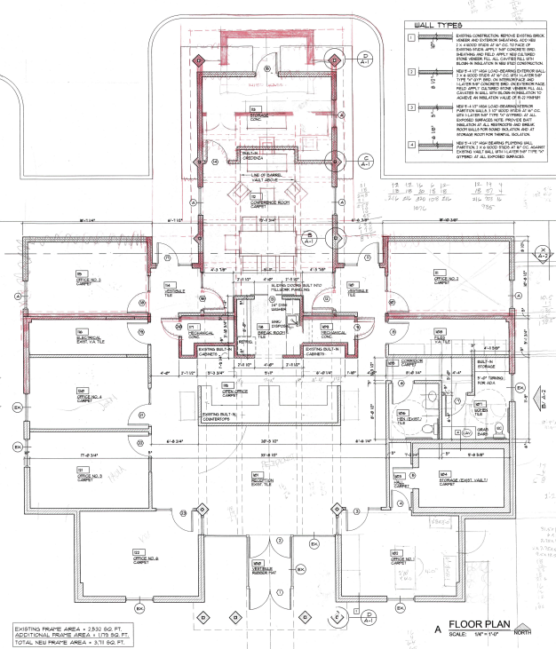

* 3,711 Square Foot Building (+/-)
* $730,000 Purchase Price
* .95 Acre Site (+/-)
* Zoned: 0-2
* Covered Parking

Managing Broker

405.210.6772 (mobile)

randy@avenuecre.com

**5030 N. May Ave, #435**

**Oklahoma City, OK 73112**

**WWW.AVENUECRE.COM**

Managing Broker

405.210.6772 (mobile)

randy@avenuecre.com

RANDY VAILLANCOURT